**AI/ML Intern – Bhavya**

**Day 4 Task 3**

**Learning Topics:**

* Training ML models.
* Classification basics (using Logistic Regression).
* Model evaluation with accuracy.

1. **Training ML models:**

Training a machine learning (ML) model is essentially the process of teaching a computer program how to identify patterns and make informed predictions based on data. This can be likened to training a pet through repeated examples and feedback until the desired behavior is learned.

**Analogy to Real-Life Learning**

* Training ML models is similar to teaching a dog a new trick.
  + Repeated examples and positive reinforcement lead to improved performance.
* In ML:
  + Data examples are provided.
  + The model adjusts itself through feedback.

**The Model as an Adjustable Mathematical Formula:**

* The ML model starts with an initial hypothesis, often represented mathematically.
* Example: Predicting house prices.
  + Input data might include:
    - House size
    - Location
    - Previous sale prices
* The model iteratively adjusts its internal parameters to minimize prediction errors.

**Algorithms and Pattern Recognition**

* Various algorithms are employed (e.g., decision trees, neural networks).
* During training:
  + The model processes large datasets.
  + It attempts to recognize meaningful patterns (e.g., keywords in spam detection).
  + Continuous self-correction refines predictive accuracy.

**Requirements for Effective Training**

* **Large Volumes of Data:** Abundant, diverse data are necessary for robust learning.
* **Computational Resources:** Significant processing power is often required, especially for complex models.

**Outcome of Training**

* Once training is complete, the model is capable of making predictions on new, unseen data.
  + Examples:
    - Classifying emails as spam or not spam.
    - Estimating house prices based on input features.

1. **Classification basics (using Logistic Regression):**

Classification in machine learning refers to the task of organizing data into distinct categories. This process is fundamental in various applications, such as identifying whether an email is spam or not, or determining if an apple is ripe based on its characteristics.

**Understanding Logistic Regression**

*Definition and Purpose*

* Logistic Regression is a foundational algorithm widely used for binary classification tasks.
* It enables models to predict one of two possible outcomes (e.g., yes/no, spam/not spam).

*Key Characteristics*

* **Simplicity:** Easy to implement and interpret.
* **Speed:** Efficient for datasets with straightforward features.
* **Interpretability:** Provides clarity on how input features influence the prediction.

**How Logistic Regression Works**

*Feature Analysis*

* Examines input features (such as color and size for apples, or specific words in emails).
* Calculates the probability that a given data point belongs to a particular category.

*Decision Process*

* Assigns a probability score to each possible outcome.
* Selects the category with the highest probability as the predicted class.

**Training the Model**

* The model is trained using labeled examples (e.g., emails marked as spam or not).
* It iteratively adjusts its parameters to reduce classification errors.
* Through exposure to patterns (such as frequent spam phrases like “win money”), the model refines its predictions.

**Applications and Suitability**

* Logistic Regression is especially suitable for simple classification problems.
* Common use cases include predicting customer purchase decisions based on demographic features or identifying spam emails.
* It serves as an accessible entry point for those new to machine learning.

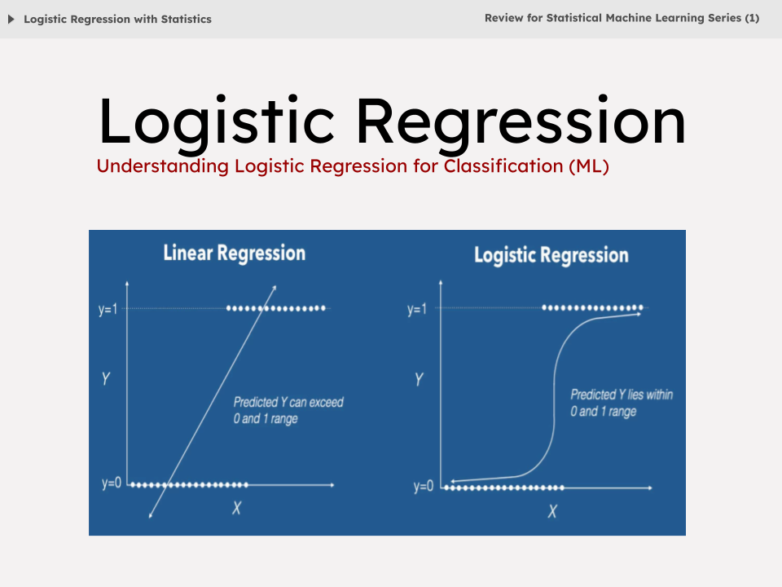

1. **Model evaluation with accuracy:**

Model evaluation is central in machine learning. The objective? To determine if a model actually performs well on data it hasn’t seen before—not just the stuff it memorized.

**Accuracy as a Metric**

* **Definition:**  
  Accuracy is one of the most basic ways to measure how well a classification model works. Quite simply, it’s the percentage of correct predictions out of the total number of cases.
* **Example:**
  + Suppose you’re classifying emails as “spam” or “not spam.”
  + Out of 100 emails (60 spam, 40 not spam), imagine the model correctly identifies 50 spam and 35 not-spam.
  + That’s 85 correct predictions out of 100, so an accuracy of 85%.

**Limitations of Accuracy**

* **Imbalanced Data:**
  + Accuracy can be misleading when the dataset is imbalanced.
  + For instance, if 90% of emails are “not spam,” a model predicting “not spam” every time achieves 90% accuracy, yet it fails to identify actual spam.
  + In such cases, accuracy alone does not reflect the model’s effectiveness.

**Evaluation Process**

* **Data Splitting:**
  + Data is typically divided into training and testing sets.
  + The model learns patterns from the training set and is evaluated on the testing set.